Minutes – RK Hall Feedback / Production HWT Calibration Process
September 10, 2018
1:00 PM to 1:30 PM

Attendees: Jason Moser, Dorian Lewis, Eric Hayes, Yan Zhang, Brian Norman, Clint Van Winkle, Sharayu Ghangrekar, John Vaders, James Galante, Gary Hockenbury

Absent: Finch Troxler, Dan Pratt

Situation:
- Thursday September 6th, 2018
  - Dean Arrives at RK Hall to calibrate Standard WheelTracker
  - During Step 5 of the calibration, Dean receives the following error
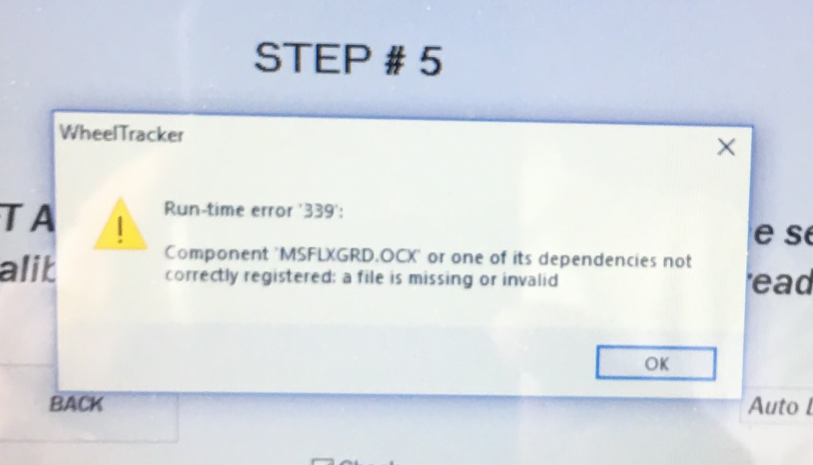
  - Sharayu sent him
  - Dean attempts to use his laptop, but battery is dead, he leaves to charge the computer
- Friday September 7th 2018
  - Deans computer will not connect to the PLC receiving the following error
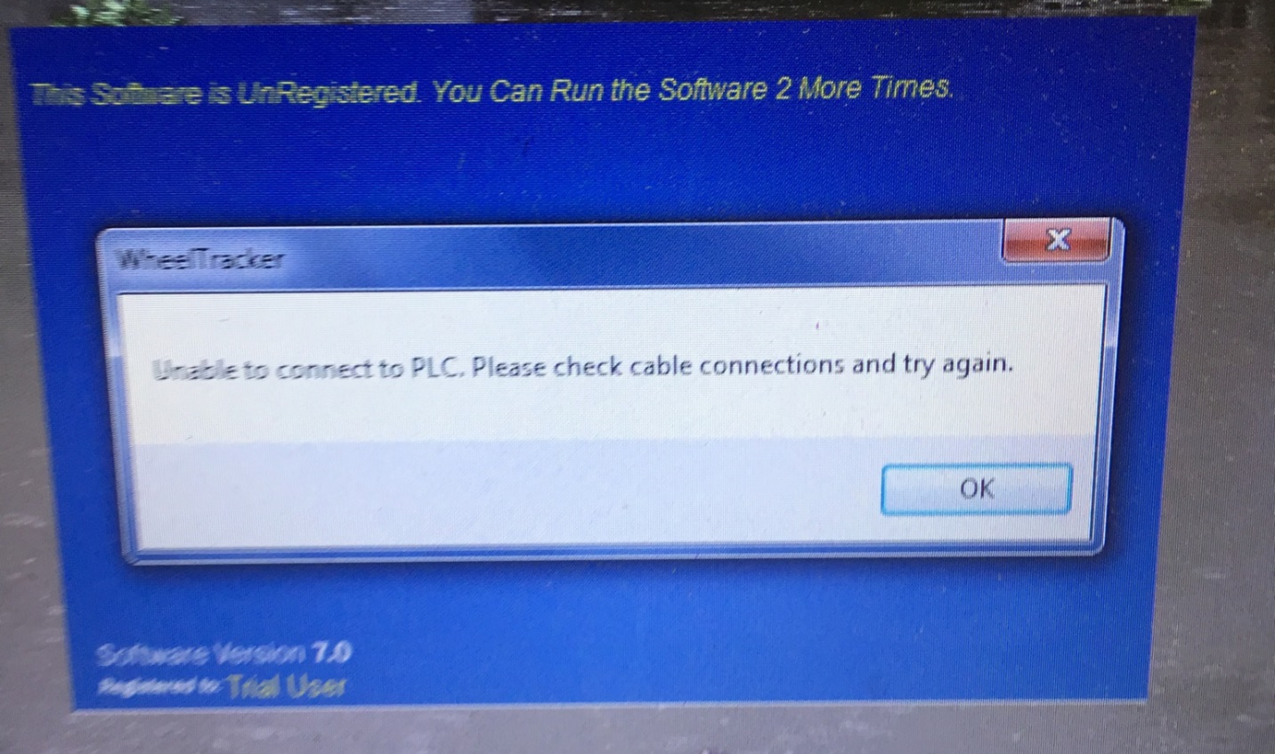
RK Hall Solution:
- Dean was going to ship gauge blocks to RTP, and is now going to ship gauge blocks to Pete
- Dorian is going to prepare a computer to do the calibration
- Eric to ship Computer to Pete
- Pete
  - Install CoDeSys on his laptop
  - Receive
    - Gauge Blocks
    - Computer
  - Visit RK Hall early next week if possible
  - Use laptop to check voltage on bailiffs
  - Use WheelTracker computer to calibrate
- Clint to Call Richard at RK Hall
- Michael Dixon to call his contact at RK Hall

Long-Term Solution:
- Clint to change procedure so that calibration is done at RTP with the computer to be shipped out
- John/Eric Technicians to have their own gauge blocks
- Jason/Brian make CoDeSys available on your respective
  - Service drives
  - NPD drives
- Yan will write possible procedure for connecting to PLC when receiving “Unable to connect to PLC” error

