03.25.2020
Tester: Harry Fu
Test Place: Troxler Labs
Test process and result:
1)Initial checkup
Three Batteries. One(#1) is broken and exploded and the other two(#2,#3) are intact.
See the following pictures Fig1~Fig3
Battery Type: Tenergy Nickel-Cadmium 5000mAh Nicd Rechargable
2) Battery voltage
#1: exploded ; Label as 6-22-2016;
#2: intact; Voltage = 1.259V
#3: intact; Voltage = 1.329V

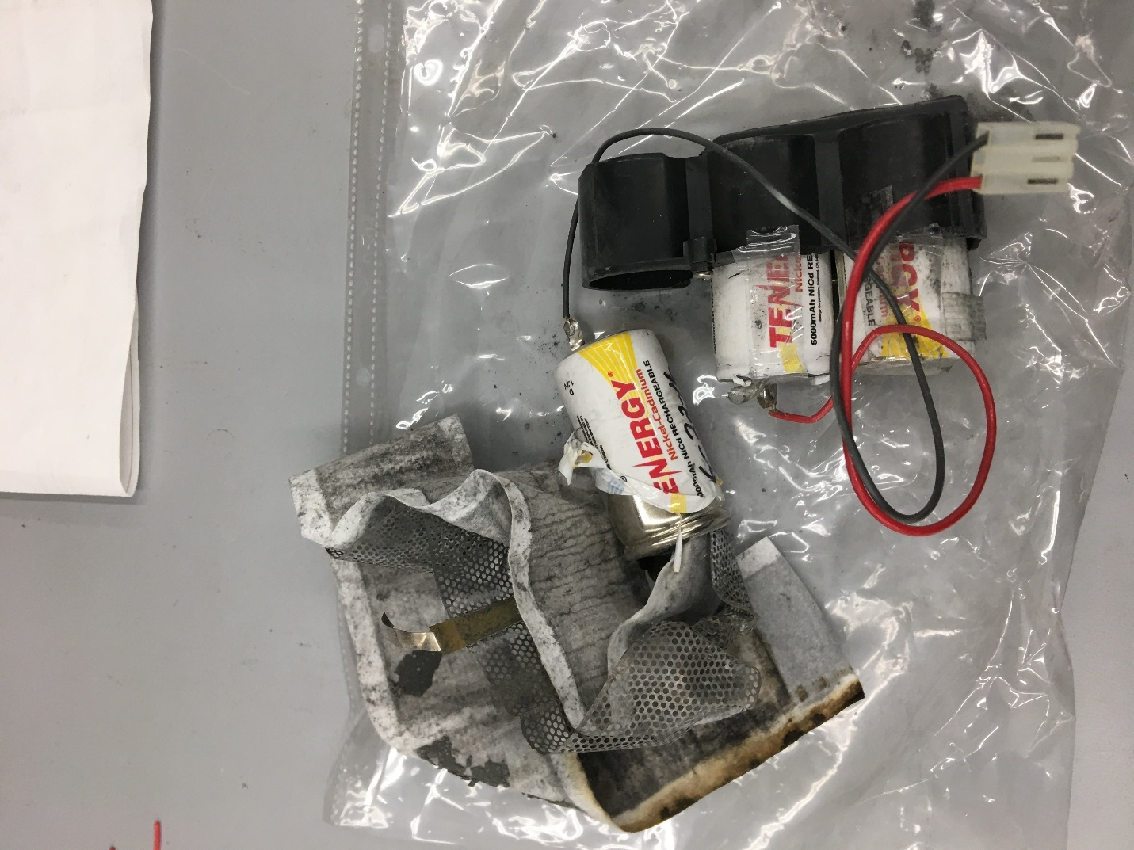
Fig1
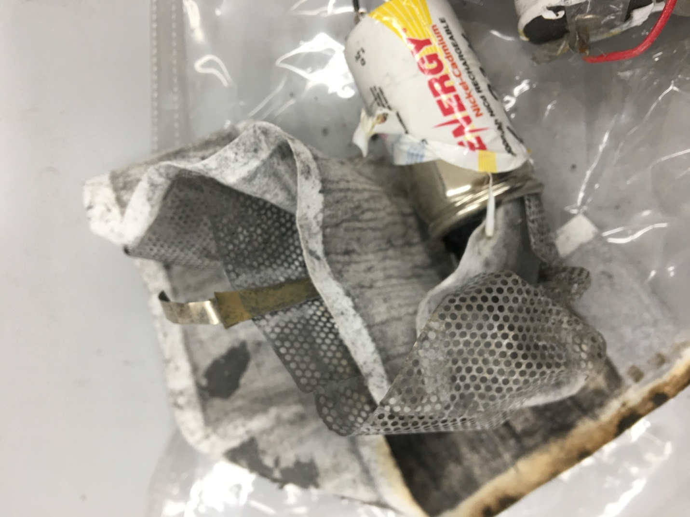

Fig2
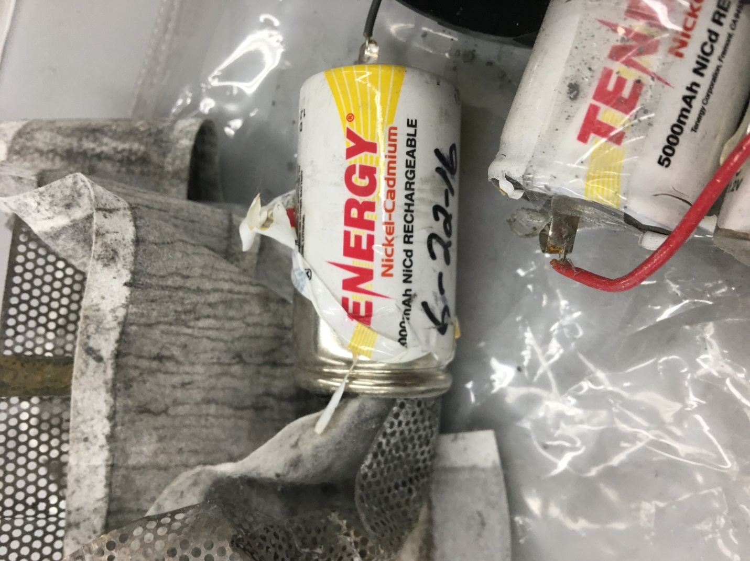
Fig3

